**UNDERTAKING LETTER**

I Mr./Ms. Sakshi Jadhav studying in AISSMS Institute of information Technology,Pune,Maharashtra will abide by the rules and regulations of the Urban Vision Hackathon being conducted at the Indian Institute of Science (IISc), Bangalore on June 21 and 22, 2025, and follow all the guidelines and safety norms of IISc. I also take sole responsible for my safety and for any untowardly incidents that may happen during my visit. The hackathon organizers or IISc will not be held responsible for the same. Further, I also confirm that I have obtained permission from my parents/guardians and Principal/HOD of my college to attend the hackathon.

_______________________________________

Signature of the Participant

Name: ______Sakshi________________________

Date: _________17/06/2025_____________________

Phone Number: _____9699401793_________________________

Email Address: ________sakshijadhav788757@gmail.com______________________

Postal Address: ______55-56 ,Shivajinagar,pune,maharashtra,india_______________________

______________________________

City/Pincode: _____410014_______________________

**CONSENT LETTER**

I give permission for the above signed to participate in the Urban Vision Hackathon at IISc, Bangalore on June 21 and 22, 2025. I will ensure that the participant will abide by all the rules and regulations of IISc and the hackathon during their visit, and uphold their conduct and safety. I also understand that IISc will not be providing any on-campus accommodation or making any travel arrangements for them.

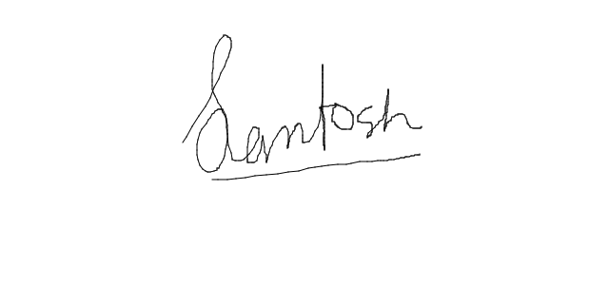_______________________________________

Signature of the Parent

Name: ________________Santosh Jadhav______________

Relationship/Designation: _________Father_____________________

Date: __________________17/06/2025____________

Phone Number: ________7887577608______________________

Email Address: ___________sj6532896@gmail.com_________________

Postal Address: ___________Balaji fertilizer mondha road dharmabad,nanded,maharashtra,india___________________

______________________________

City/Pincode: _________431809__________________